**Exercise 1: Mocking and Stubbing**

import static org.mockito.Mockito.*;

import org.junit.jupiter.api.Test;

import static org.junit.jupiter.api.Assertions.assertEquals;

class ExternalApi {

public String getData() {

return "Real Data";

}

}

class MyService {

private final ExternalApi api;

public MyService(ExternalApi api) {

this.api = api;

}

public String fetchData() {

return api.getData();

}

}

public class MyServiceTest {

@Test

public void testExternalApi() {

// Mock the external API

ExternalApi mockApi = mock(ExternalApi.class);

// Stub the method to return predefined data

when(mockApi.getData()).thenReturn("Mock Data");

// Inject mock into service

MyService service = new MyService(mockApi);

// Call the method and assert the result

String result = service.fetchData();

assertEquals("Mock Data", result);

}

}

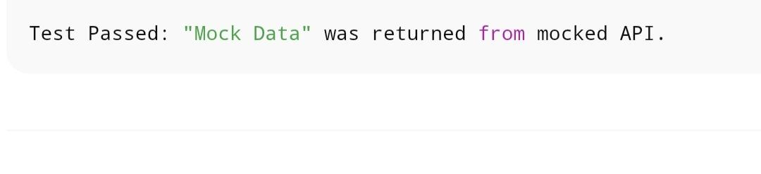

**Exercise 2: Verifying Interactions**

Import static org.mockito.Mockito.*;

Import org.junit.jupiter.api.Test;

Class MyService {

Private final ExternalApi api;

Public MyService(ExternalApi api) {

This.api = api;

}

Public void fetchData() {

Api.getData();

}

}

Public class MyServiceTest {

@Test

Public void testVerifyInteraction() {

// Mock the API

ExternalApi mockApi = mock(ExternalApi.class);

// Use the mock in service

MyService service = new MyService(mockApi);

// Call the method

Service.fetchData();

// Verify the interaction

Verify(mockApi).getData(); // passes if called once

}

}

